Factor Analysis in SPSS (JASP is easier!)

About PIAAC
The Program for the International Assessment of Adult Competencies (PIAAC) is a program of assessment and analysis of adult skills. The major survey conducted as part of PIAAC is the Survey of Adult Skills. The Survey measures adults’ proficiency in key information-processing skills - literacy, numeracy and problem solving - and gathers information and data on how adults use their skills at home, at work and in the wider community.
This international survey is conducted in over 40 countries/economies and measures the key cognitive and workplace skills needed for individuals to participate in society and for economies to prosper.
Survey of Adult Skills (PIAAC) - PIAAC, the OECD's programme of assessment and analysis of adult skills
https://www.oecd.org/skills/piaac/The_Survey%20_of_Adult_Skills_Reader's_companion_Second_Edition.pdf
The subsetted spss file is called sub_prgusap1_2017.sav
If you want to look at all the data its in the spss file called prgusap1_2017.sav
TASK 1: Factor Analysis
The above dataset is very interesting. Several variables were identified measuring adults’ proficiency in various reading and numeracy skills at home and at work in the PIAAC survey. Note that for this analysis I downloaded the 2017 dataset for the US sample. You should make sure you can do that on your own.
The variables identified are continuous variables with higher scores meaning more skills in that domain.
- Index of use of numeracy skills at home (basic and advanced derived) (NUMHOME)
- Index of use of numeracy skills at work (basic and advanced derived) (NUMWORK)
- Index of use of ICT skills at home (derived) (ICTHOME)
- Index of use of reading skills at home (prose and document texts—derived) (READHOME)
- Index of use of task discretion at work (derived) (TASKDISC)
- Index of learning at work (derived) (LEARNATWORK)
- Index of use of planning skills at work (derived) (PLANNING)
- Index of readiness to learn (derived) (READYTOLEARN)
- Index of use of ICT skills at work (derived) (ICT WORK)
- Index of use of influencing skills at work (derived) (INFLUENCE)
- Index of use of reading skills at work (prose and document texts—derived) (READWORK)
- Index of use of writing skills at work (derived) (WRITEWORK)
- Index of use of writing skills at home (derived) (WRITEHOME)

We will use factor analysis here to reduce the number of literacy variables across work and home domains. Factor analysis groups variables with similar characteristics together. Given that, what types of relationships between variables and factors do you expect to find here?
Here are the stages
- A correlation matrix is generated for the variables. This is comprised of correlation coefficients.
- Factors are extracted from the correlation matrix based on the pattern of correlations in the matrix
- The factors are then rotated in order to maximize the relationship between the variables and the factors
To do this in SPSS (please do not, use JASP!)
Analyze Dimension Reduction Factor
Search for the variables we will be using here and place them in the Variables list:

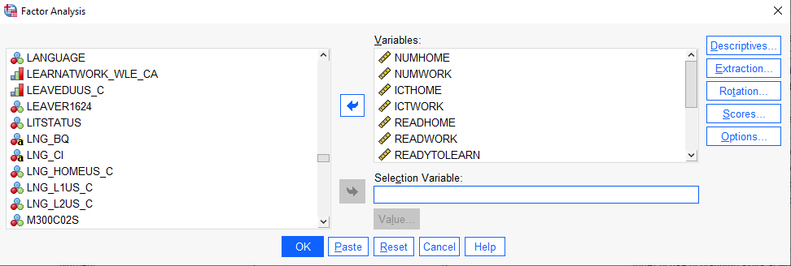

Click on the DESCRIPTIVES button and its dialogue box will be loaded on the screen. Within this dialogue box select the following check boxes Univariate Descriptives, Coefficients, Determinant, KMO and Bartlett's test of sphericity, and Reproduced. Click on Continue to return to the Factor Analysis dialogue box. The Factor Analysis: Descriptives dialogue box should be completed as shown below
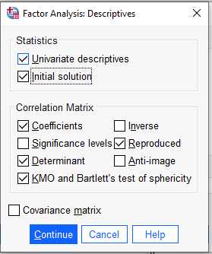
From the Factor Analysis dialogue box click on the EXTRACTION button and its dialogue box will be loaded on the screen. Select the check box for Scree Plot. For METHOD change ‘Principle Components’ to ‘Maximum Likelihood.’ Click on Continue to return to the Factor Analysis dialogue box. The Factor Analysis: Extraction dialogue box should be completed as shown below
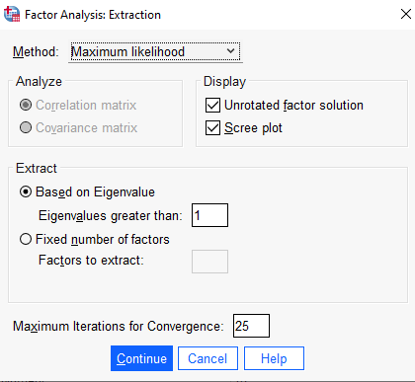
From the Factor Analysis dialogue box click on the ROTATION button and its dialogue box will be loaded on the screen. Click on the radio button next to Varimax to select it. Click on Continue to return to the Factor Analysis dialogue box. The Factor Analysis: Rotation dialogue box should be completed as shown below.
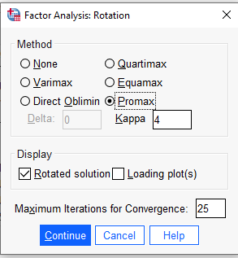
From the Factor Analysis dialogue box click on the OPTIONS button and its dialogue box will be loaded on the screen. Click on the check box of Suppress absolute values less than to select it. Type 0.50 in the text box. Click on Continue to return to the Factor Analysis dialogue box. Click on OK to run the procedure. The Factor Analysis: Options dialogue box should be completed as shown below.
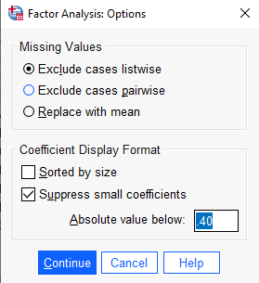

Task 2: Interpretation of output
The first output from the analysis is a table of descriptive statistics for all the variables under investigation. Typically, the mean, standard deviation and number of respondents (N) who participated in the survey are given. The highest mean is associated with the variable ‘Index of readiness to learn’ (2.70, sd = .950, N = 1321).
The next output from the analysis is the table of correlation coefficients. A table of this size is a bit unwieldly, but I would point out the most highly associated variables. Here, the variables “use of reading skills at home” and “numeracy skills at home” and “use of reading skills at home” and “ICT skills at home” are the most highly correlated variables (r = .463, r = .461).
Kaiser-Meyer-Olkin (KMO) and Bartlett's Test : measures strength of the relationship among variables
The KMO measures the sampling adequacy which should be greater than 0.5 for a satisfactory factor analysis to proceed. If any pair of variables has a value less than this, consider dropping one of them from the analysis. Looking at the table below, the KMO measure is 0.795 which is good.
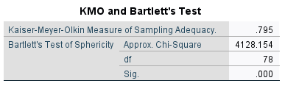
Regarding sample size, with 13 variables, the minimum sample size needed (?) is far surpassed here…
Bartlett's test is another indication of the strength of the relationship among variables. This tests the null hypothesis that the correlation matrix is an identity matrix. An identity matrix is matrix in which all of the diagonal elements are 1 and all off diagonal elements are 0. You want to reject this null hypothesis that the correlation is an identity matrix. From the same table, we can see that the Bartlett's test of sphericity is significant That is, its associated probability is less than 0.05. In fact, it is actually < .001 so we reject the null hypothesis that the that correlation matrix is an identity matrix.
Communalities The next item from the output is a table of communalities which shows how much of the variance in the variables has been accounted for by the extracted factors. For instance, 64.9% of the variance in use of ICT skills at home is accounted for while only 6.8% of the variance in task discretion at work is accounted for. Based on this result, would you consider removing ICT skills or task discretion?

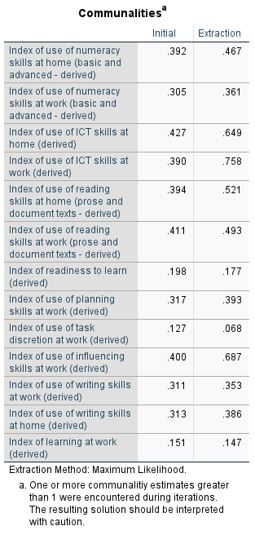
Of the variable “ICT skills at work, 75.8% of the variance can be described with the four factors
Of the variable “use of numeracy at work, 46.7% of the variance can be described with the four factors
Total Variance Explained The next item shows all the factors extractable from the analysis along with their eigenvalues, the percent of variance attributable to each factor, and the cumulative variance of the factor and the previous factors. Notice that the first factor accounts for 25.59% of the variance, the second 7.9%, the third 5.6% and the fourth 2.87. All the remaining factors are not significant.
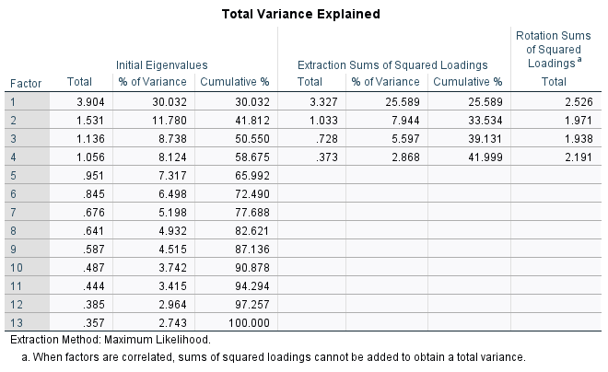
Factor 1 explains 25.59% of the total variance, Factor 2 explains 7.94% of the total variance, etc.

Scree Plot The scree plot is a graph of the eigenvalues against all the factors. The graph is useful for determining how many factors to retain. The point of interest is where the curve starts to flatten. It can be seen that the curve begins to flatten between factors 3 and 4. Note also that factor 4 has an eigenvalue (standardized variance associated with a factor) greater than 1 but five does not, so only four factors have been retained.
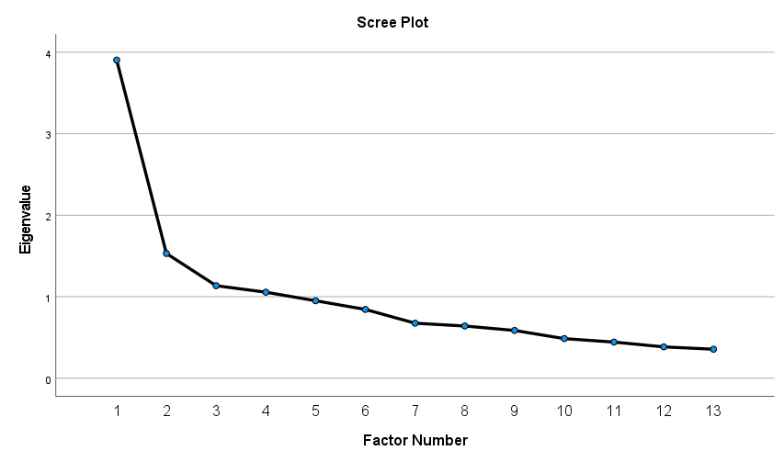
Component (Factor) Matrix The table below shows the loadings of the eight variables on the four factors extracted. The higher the absolute value of the loading, the more the factor contributes to the variable. The gap on the table represents loadings that are less than 0.3 (based on our selection), this makes reading the table easier. We suppressed all loadings less than 0.3 (or can do .4).
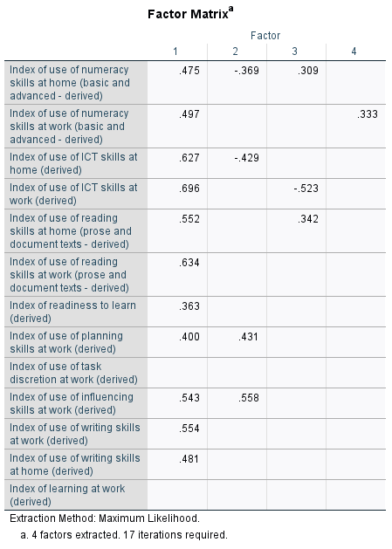

Rotated Component (Structure) Matrix The idea of rotation is to reduce the number factors on which the variables under investigation have high loadings. Rotation does not actually change anything but makes the interpretation of the analysis easier. Looking at the table below, we can see that reading, writing and numeracy skills at home are substantially loaded on Factor 1 while ICT skills at home and work are loaded on Factor 3, planning and influencing skills at work are substantially loaded on Factor 2, and numeracy at work, reading at work, and writing at work are substantially loaded on factor 4. These factors can be used as variables for further analysis.
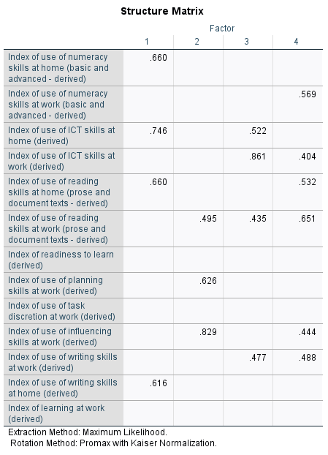
Factor Correlation Matrix
Recall that because we used an oblique rotation, our factors will be correlated. As evident from the above structure, factor 4 is highly correlated with factors 1 and 2. We might think of redoing the analysis with fewer factors (we can justify 3 here), or removing some offending variables.
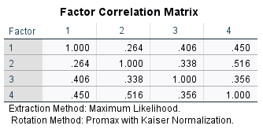
Task 3: Write-up
An exploratory factor analysis of the PIAAC questionnaire was conducted using the maximum likelihood method of extraction, with the Promax oblique rotation method. Justification for using the oblique rotation method is due to the assumed conceptual overlap between skills across various domains (i.e., work, home). Communalities ranged from .068 to .758 (see Table 1.). The pattern matrix (see Table 2.) was used to interpret the factor loadings. Eigenvalues of ≥1 and the scree plot were used to interpret the number of factors in the data set.

Table 1.
Communalities for Exploratory Factor Analysis of the PIAAC Questionnaire (N = 1323).
Item No. | Items | Communalities
1 | Numeracy at home | .487
2 | Numeracy at work | .361
3 | ICT skills at home | .649
4 | ICT skills at work | .758
5 | Reading skills at home | .521
6 | Reading skills at work | .493
7 | Readiness to learn | .177
8 | Planning skills at work | .393
9 | Task discretion at work | .068
10 | Influencing skills at work | .687
11 | Writing skills at work | .353
12 | Writing skills at home | .386
13 | Learning at work | .147

Table 2.
Pattern Factor Loadings for Exploratory Factor Analysis of a Social Support Questionnaire (N = 367).
 |  | Factor
Item No. | Items | 1 | 2 | 3 | 4
1 | Numeracy at home | .660
2 | Numeracy at work |  |  |  | .569
3 | ICT skills at home | .746 |  | .522
4 | ICT skills at work |  |  | .861 | .404
5 | Reading skills at home | .660 |  |  | .532
6 | Reading skills at work |  | .495 | .435 | .651
7 | Readiness to learn
8 | Planning skills at work |  | .626
9 | Task discretion at work
10 | Influencing skills at work |  | .829 |  | .444
11 | Writing skills at work |  |  | .477 | .488
12 | Writing skills at home | .616
13 | Learning at work
Note. Factor loadings are in boldface. Extraction Method: Maximum Likelihood. Rotation Method: Promax Rotation. Only factor loadings ≥.4 are displayed.

.

Figure 1. Scree Plot for Exploratory Factor Analysis of the PIAAC Questionnaire (N = 1323).
Loading Patterns
As can be seen in Table 2. and Figure 1., the results showed that the 13 items loaded onto four factors, explaining 42.0% of the total variance.
Factor 1 (Numeracy and Literacy at Home)
Factor 1 contained 4 items (items 1, 3, 5, and 12), which appeared to measure demonstrated proficiency in skills performed at home (e.g. “Use of numeracy skills at home.”) and was named Demonstrated Home Skills. A follow-up reliability analysis found factor 1 to have adequate internal consistency (Cronbach’s  = .76).
Factor 2 (Leadership Skills)
Factor 2 contained 2 items measuring planning and influencing skills at work (e.g. “use of planning skills at work”) and was named Leadership skills at work.
Factor 3 (Technological Skills)
Etc…
Factor 4 (Numeracy and Literacy at Work)

Factor Correlations
Table 3.
Factor Correlations for Exploratory Factor Analysis of the PIAAC Questionnaire (N = 1323).
Factor | 1 | 2 | 3 | 4
1 (Numeracy and Literacy at Home) | -
2 (Leadership Skills) | .264 | -
3 (Tech skills) | .406 | .338 | -
4 (Numeracy and Literacy at Work) | .450 | .516 | .356 | -

Table 3 shows the factor correlations which are highest among factors 1 and 2 (r = .516).

